*Let’s all go to the lobby, let’s all go to the lobby, let’s all go to the lobby, to get ourselves a snack*

**IN THIS ISSUE:**

* **New Tech Saves Gas and it’s not Electric**
* **Members’ Ride 1976 Cutlass Supreme**
* **Hemmings Picks it’s favorite Oldsmobiles**
* **How to makes cars last longer**
* **An Oldsmobile Obsession**
* **1968 Hurst/Olds: It’s about foot pounds**
* **28th Annual Rocket Roundup in Olds**
* **Oldsmobile Classifieds**
* **And even more…**

SPRING 2022

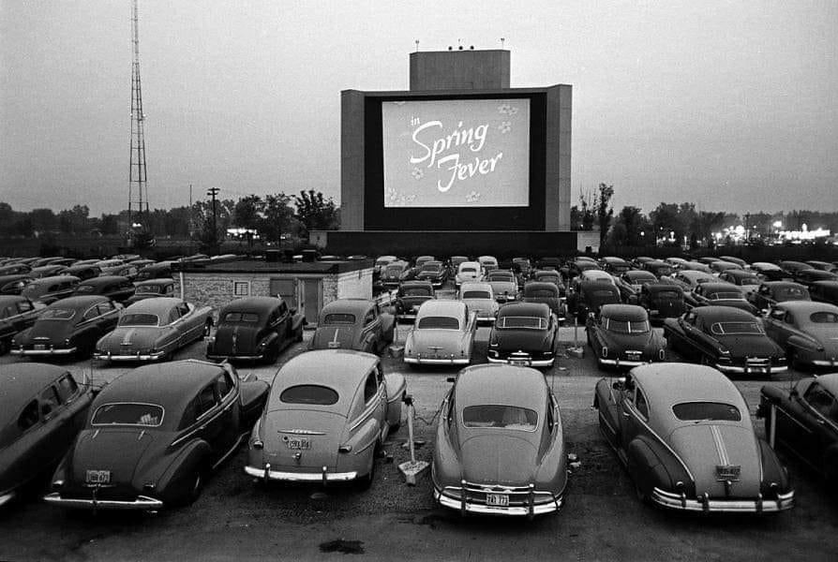

Volume 31, Number 1 – Quarterly 26 Page Newsmagazine of the Northern Lights Oldsmobile Club

[**Facebook**:](https://www.facebook.com/groups/204974969532272/) [**Website**:](http://www.oldsclub.ca/) Editor: Ken Pilidis – [president@oldsclub.ca](mailto:president@oldsclub.ca) – Sherwood Park, AB

Spring is in the air and I for one am looking forward to the summer of car shows and cruise nights. Time to reconnect with people that I haven’t seen in a few months.

**

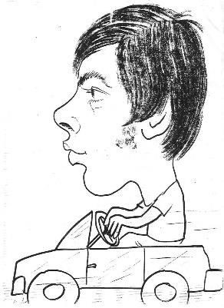

There is a new Canadian Muscle Car magazine out. It focuses mostly on Canadian cars but has US cars as well. It also focuses on car events Across Canada and the US. In the winter 2022 Edition, I noticed at least one car that was at the 2021 Rocket Roundup. Since Peterson Publishing cancelled, *Muscle Car Review*, this magazine fills the void for this craving. Check it out.

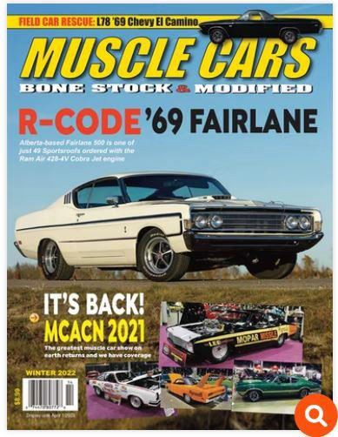

**442**



Speaking of car shows, there was a shooting at a car show in Arkansas about 10 days ago. Who ever heard of something like that? It brings home the adage “Make sure you always know your surroundings”, as there are crazies everywhere.

The banquet for this year’s Rocket Roundup in Olds is a go as of this printing. The meal, like everything else has gone up in price. We are being charged $24.95. per meal. The club will hold the price we had the last time we hosted a banquet. We will charge $25.00 per meal. The choices are as in the past, chicken or beef with vegetables, potatoes and desert. As in the past, if some are still hungry after everyone has eaten, you can go back for seconds. I’m promoting the banquet because If we get 50 people to come to it, the club will make $2.50. 😊

Since we’re having the banquet, that means the show in a go. We will meet in the Town of Olds on the third Saturday in July. If you can volunteer to park cars, register late registrations, give some door prizes away, it will be very much appreciated. Remember, the earlier you register the faster you get to pick your door prize. See the poster on page 9. Let’s see some special cars again.

I remember telling my kids years ago when they were about 10 to “Come see this special vehicle that has 6 wheels and flies!” They were in the basement playing video games with their friends. I could hear a commotion as they were running up the stairs with their friends in tow and yelling for their mother to come outside quickly. One said “This is gonna be so cool.” My wife Karen also came outside to see what was going on. Last time she heard the kids this excited, I had come home with a Corvette. She wasn’t impressed. When they all got outside they looked down the street and then everyone started looking skyward. Karen looked skyward too because the kids were. “WHERE IS IT DAD?!” “Right there,” as I pointed down the street. Everyone looked at me with a perplexed look on their faces. “THAT’S A GARBAGE TRUCK!” “Yeah” I said, “Six wheels and flies.” This time, no one was impressed. 😊

Make sure you join our [**Facebook page**](https://www.facebook.com/groups/204974969532272) to see what’s coming up for swap meets, car shows in between newsletters. Have a great spring and I hope to see you at the show.

Ken

*Club Sponsors*

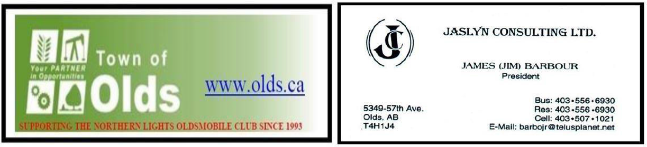

[AUTO APPRAISALS BY TREFKO](https://www.trefko.com/) [FUSICK AUTOMOTIVE](http://www.fusickautomotiveproducts.com/)

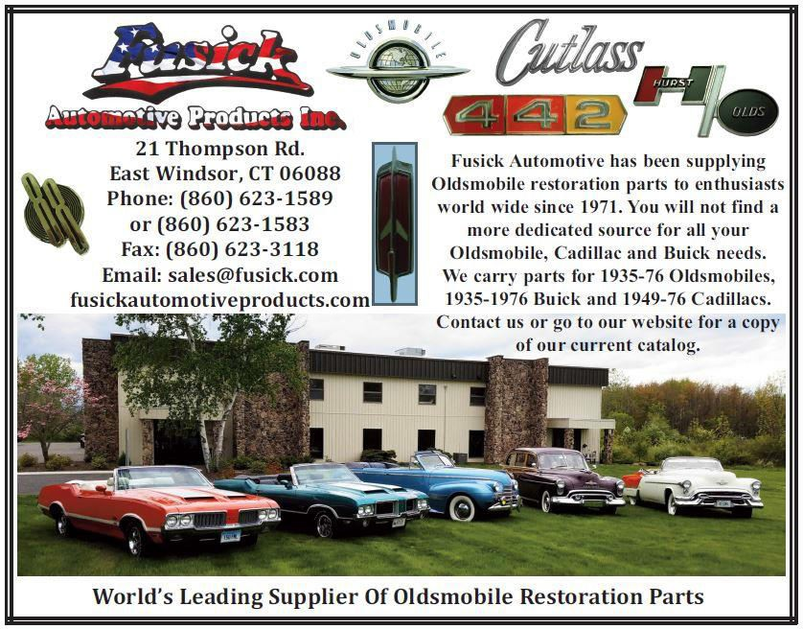

****

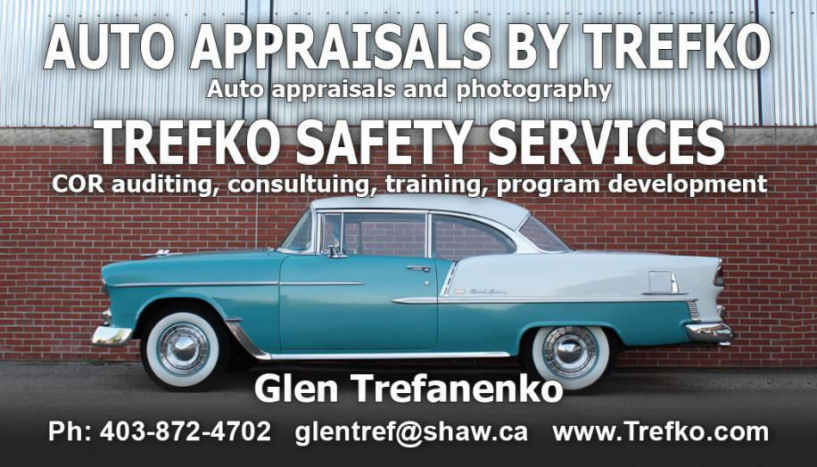

***

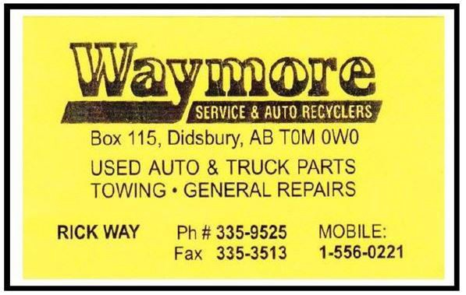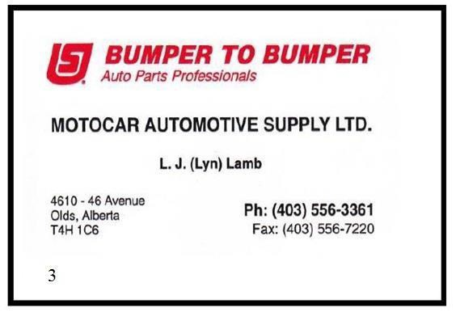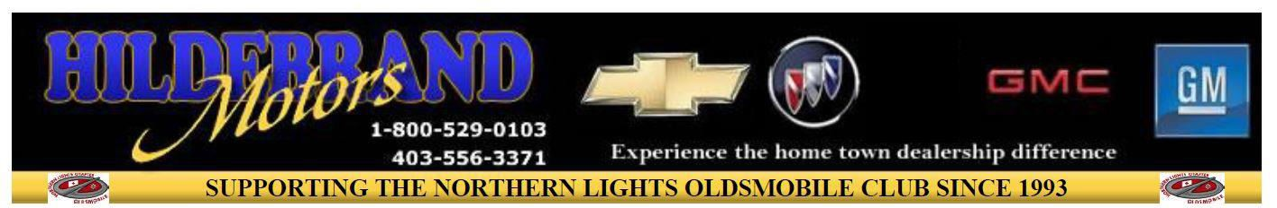

*****

*

**** = expires this issue



### STEVE HARRIS, NO. 0759 CARON, SK

I currently own a 1976 Oldsmobile Cutlass Supreme. I picked it up about 8 or 9 years ago from a fellow in Swift Current. Although he was reasonably careful with the car, it did require a lot of work to bring it to its present condition.

Anyway I got the car and Marilyn followed me home to Caron, a trip of about 180 km. Nothing eventful about the drive other than the car had been in storage for a number of years, so I just varied the speed to sort of break it in without being too hard on it. I must have been doing something right because I got it home without any problem at all. I parked it in the garage and the next morning, went out to admire it and to start it up. Absolutely nothing happened! Getting it into the garage must have been the last gasp for the fuel pump because it was just done like dinner!

I started to inspect what I had, and it turned out pretty good actually. The car had about 62,000 mi on it and was all 100% original. But it wasn’t 100% originally good! I did the basic inspection of the motor, I had good compression, good oil pressure and no unusual noise so that was a good start. The rest of the drive train was in good shape but over the years I have pretty much rebuilt or replaced it entirely, just so that I can minimize the chances of a surprise on a road trip! For the past few years, I have been dealing with a shop in Moose Jaw and he has done a very nice job for me. I am getting to the point now that some of it is beyond me for knowledge and ability.

Anyway, over the years the car has been pretty much restored completely. The body and paint needed a bit of repair which included a compete paint job. Surprisingly very, very minimal rust around one wheel well and the driver’s seat had to be redone. Other than that, the body is all original. Marilyn and I decided we wanted it to be as close as original for the paint colour. So Marilyn and the painter picked out the colour for the car. For myself, when it comes to shades like this, I can hardly tell them apart. Anyway, so there they both were with all these paint chips checking this and that, looking at them in the sun and whatever. After about 15 chips being examined and nobody can make up their mind I just walked over and said OK, pick one and let’s get going. When it is that close and you can’t decide, anything is going to work.

So, a long story short, the car is done. At least as much as they are ever going to be, I guess. There is always something you want to add or change but hey, that is part of the joy of having the car. However, after reading the last newsletter, that picture of the Grant steering wheel looks kind of good. I know Steve Zibresky has one that he wants to sell me. And he has sold me a number of parts for my car so perhaps if this years’ show is a go, I will have to give Steve a call and see what we can do. Have a good Spring and Summer folks, get in lots of shows in your area and as many cruise nights as possible. Hope to see you at the Olds show in Olds.

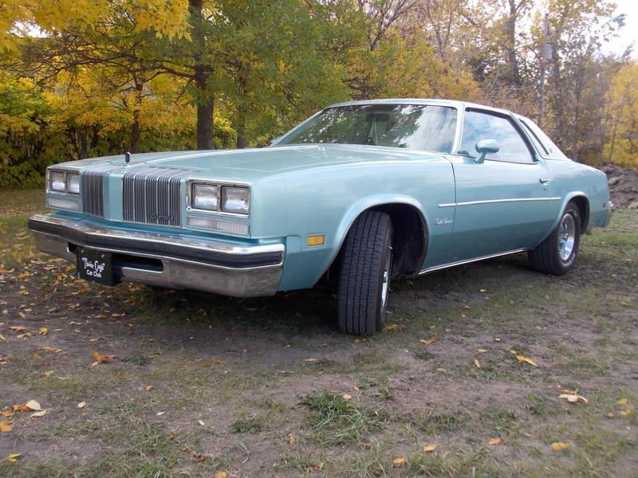

### LOOKING BACK TO 1976

**January:** "The Bionic Woman" with Lindsay Wagner debuts on ABC (later NBC) - Pittsburgh Steelers defeat Dallas Cowboys in Superbowl X 21 -17 at Miami - Supersonic Concorde, 1st commercial flights, by Britain & France

**February:** 12th Winter Olympic games open in Innsbruck, Austria, - Darryl Sittler, Toronto Maple Leafs, sets NHL record with 10 points in a game

**March:** 1st female cadets accepted to West Point Military Academy - Patricia Hearst convicted of armed robbery - AL approves purchase of Toronto Blue Jays franchise by Labatt Brewing for $7M - Queen Elizabeth II sent out the first royal email, from the Royal Signals and Radar Est.

**April:** Harold Wilson resigns as James Callaghan becomes PM of the United Kingdom - Barbara Walters becomes 1st female nightly network news anchor - Elections in Vietnam for a National Assembly to reunite the country

**May:** Stanley Cup: Montreal Canadiens sweep Philadelphia Flyers in 4 games, their 1st cup of 4 in a row - Muhammad Ali TKOs Richard Dunn in 5 for heavyweight boxing title in Munich - Bobby Unser sets world record for fastest pit stop (4 seconds)

**June:** Queen's "Bohemian Rhapsody" goes gold - Boston Celtics beat Phoenix Suns, 4 games to 2 for NBA Championship - CN Tower in Toronto, tallest free-standing structure (555 m) opens

**July:** Operation Entebbe: Israel rescues 229 Jewish passengers taken hostage in Uganda - USA Celebrates its Bi-Centennial - XXI Olympic Summer Games open in Montreal - US Viking 1 lands on Mars at Chryse Planitia, 1st Martian landing

**August:** 1st approach & lands test (ALT) of Space Shuttle Enterprise - USSR's Luna 24 soft-lands on Moon - Tom Brokaw becomes news anchor of Today Show

**September:** Expos’ last game at Montreal's Jarry Park, moves to the Olympic Stadium - Mao Zedong's funeral takes place in Beijing. "Charlie's Angels" starring Farrah Fawcett debuts

**October:** Helmuth Kohl's CDU wins German parliament election - Cubana Flight 455 crashes into the Atlantic Ocean after two bombs, placed by terrorists with connections to the CIA - Cincinnati Reds sweep NY Yankees, in 73rd World Series

**November:** Jimmy Carter (D) defeats Gerald Ford (R) to become US President - René Levesque's Parti Québécois wins elections in Quebec after promising not to separate without a referendum - 64th CFL Grey Cup: Ottawa Rough Riders defeat Saskatchewan, 23-20

**December:** Fidel Castro becomes President of Cuba replacing Osvaldo Dorticós Torrado - UN General Assembly re-elects Kurt Waldheim secretary-General - “The Cars” play their first gig

**Hemmings Picks its Oldsmobile Greats**

People born the year that GM pulled the plug on Oldsmobile will turn 18 in 2022. That means they grew to legal voting age having never seen a new car from Lansing. They might vaguely remember seeing a new Pontiac, as that brand’s demise came about after GM’s bankruptcy, bailout, and subsequent restructuring around 2009. Perhaps these hypothetical 18-year-olds might aspire to buy the new Buick Electra electric vehicle that Flint unveiled in September—if it ever progresses from a bold-looking concept car into production. Also, as long as they grew up in China, where the concept was shown and where this new Buick EV is slated to be built and sold.

Times have most definitely changed for Buick, Oldsmobile, and Pontiac but one thing hasn’t—the popularity of the cars those storied marques produced from the prewar era through the 21st century. The B-O-P issue of *HMN* is one of our most popular, both with readers and with sponsors. It’s for good reason: GM’s middle three divisions produced some of the most innovative, exciting, reliable, luxurious, sporty, etc. vehicles in history and they remain popular with old-car buffs today.

Recently we polled the *HMN* staff to find out what Oldsmobile vehicles intrigue them the most and why. Some of the results were surprising and clearly there was a dearth of 1950s- and 1980s-era vehicles that we’ll need to address in a future issue. Here for your perusal are the results.

**1922 OLDSMOBILE 43A**

Oldsmobile already had decades of production on the road when the 1920s dawned, and the division continued to innovate. Three model lines were available for 1922: the Model M43A "Four," which relied upon a 224-cu.in. inline-four; the Model 47 "Smaller Eight" that used a 233-cu.in. V-8; and the Model 46 "Larger Eight," which sported a 246-cu.in. V-8. The M43A sold best, representing 14,839 of the 22,758 Oldsmobiles built that year. Sending its 40 hp to the wheels via a torque tube, the four-cylinder was an advanced design that included three main bearings, a two-stage carburetor, and overhead valves, the latter disappearing after 1923 and not returning until Olds debuted the 1949 Rocket V-8. The entry-level model came as a Roadster, Coupe, Sedan, or Tourer; it was much pricier than the contemporary mass- produced Ford Model T, the range of $1,195 to $1,795 being roughly equivalent to $19,510-$29,310 in today’s dollars. Marque enthusiasts covet surviving examples.— Mark J. McCourt

**1964 OLDSMOBILE JETSTAR 1**

The first-generation Oldsmobile V-8 transformed the middle of the automobile market in the early 1950s. "Rocket 88s" became a cultural phenomenon and Oldsmobiles were desirable as never before. The 1964 model year was the last hurrah of the first-generation Rocket and Oldsmobile sent it out in style. Most attention these days is focused on the GTO-like 4-4-2, which used the new small-block V-8, but the other muscle Olds was a traditional full-size car with a 394-cu.in., 345-hp iteration of the original Rocket under its hood. The Jetstar 1, which shouldn’t be confused with the el-cheapo Jetstar 88 that Oldsmobile also marketed for ’64, was a slightly decontented version of the Starfire hardtop, designed as a price counterpart to the successful Pontiac Grand Prix. For 1965, the Jetstar 1 got a 425-cu.in. big-block version of the new V-8 and in 1966 went away entirely as Toronados took over.— David Conwill

**1964-’72 OLDSMOBILE VISTA CRUISER**

Although it wasn’t the only GM division to feature a unique station wagon roofline, Oldsmobile’s Vista Cruiser was arguably the most memorable. The Vista Cruiser made its debut late in 1964, exhibiting F-85 styling on a more comfortable 120-inch wheelbase chassis; however, its visual calling card was the elevated rear roof section with inset smoked glass panels on all but the rear-facing side, similar to the widely popular dual-deck buses operated by Continental Trailways in the 1950s and ’60s. Seemingly a selling gimmick, the glass paneled elevated roof section served two purposes: it increased headroom by

3.50 inches—or cargo space by a few more cubic feet—while providing extra ambient lighting for rear passengers. Like other models, the Vista Cruiser evolved in terms of seating capacity options, comfort and convenience equipment, and an increasing array of powerful engine choices. From 1964-’72, the Vista Cruiser found a total of 265,586 buyers, after which the ’73 adaptation of colonnade styling eliminated the iconic raised roof.— Matthew Litwin

**1973-’77 OLDS CUTLASS/SUPREME/442**

GM’s ’73 "Colonnade" A-body coupes were built for a new world. Designed to be safer and softer, the Oldsmobile Cutlass was a personal-luxury car from a division that knew a thing or two about luxurious accommodation. Coupes featured a downward-dipping beltline that delivered greater glass area, which opened up the cockpit a little more. Most were 350s topped by a two-barrel and mated to a Turbo Hydra- Matic 350, a smooth and understressed powertrain, though the optional FE2 suspension gave the chassis moves that belied its size. They were utterly conventional, but Oldsmobile was well-placed to take advantage of the personal-luxury zeitgeist: upwardly mobile, and with a reputation for both class and quality. For 1975, ’76, and ’77, the Olds Cutlass was America’s best-selling car—322,000 in a 1975 that was rough for everyone, half a million in ’76, and 632,000 in 1977, despite being the same size as the newly- downsized B-body Delta 88.— Jeff Koch

**1999 SHELBY SERIES 1**

The Series 1 was supposed to lend Oldsmobile some Shelby-performance cred like the Cobra and Shelby Mustangs had given Ford or the GLH/GLHS and Shelby Daytona had given Dodge. But Carroll Shelby’s vision of an Olds-Indy-engine-powered race car for the street became bogged down in GM bureaucracy before production ever started. Several big Oldsmobile dealers, eager for the shot in the arm this all-new Shelby sports car might give them, grabbed the torch for the Series 1 and sidestepped GM, agreeing to fund the cars themselves. They took deposits from customers and wrote checks to Shelby American, but delays, production issues, and cost overruns nearly torpedoed the entire project. In the end, the Series 1 survived a corporate takeover at Shelby American, Carroll Shelby’s ill-health before his kidney transplant, dozens of angry customers, and mixed reviews from the press. From 1998-2005, about 250 of these aluminum and composite sports cars were built, powered by Oldsmobile’s DOHC 4-liter Aurora V-8. At the end, they were sold as component cars to be assembled by the buyer or a dealer. Today, they seem to come up for sale often, priced in the neighborhood of $100,000-$150,000. The example pictured, for instance, was sold by Hemmings Auctions last year for $110,000. That’s not a pittance, but it’s a fraction of the cost of a Cobra and this is a unique rolling artifact from the dynamic history of Shelby American.— Mike McNessor

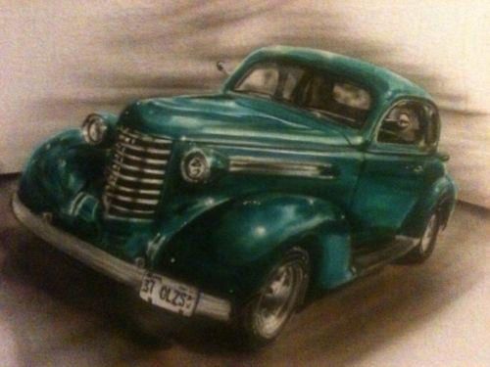

**HILDEBRAND MOTORS, 6401 46 St, OLDS, AB T4H 1L7 (403) 556-3371 - SATURDAY JULY 16th, 2022 12 NOON – 4 PM**

**OPEN TO ALL OLDSMOBILES 1897- 2004**

**MINI OLDSMOBILE ARTWORK WITH EASEL TO THE FIRST 50 PARTICIPANTS** **NLOC MEMBERS REGISTERED ON OR BEFORE JULY 9th, 2020 – $10.00**

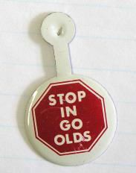

**JULY 10th – JULY 16th, - $20.00** **NON-MEMBERS - $20.00**

**SET UP FROM 10 AM -12 NOON**

**INCLUDED WITH REGISTRATION - HOT DOGS AND SOFT DRINKS, GOODY BAG AND DOOR PRIZE**

**A CHANCE TO WIN**

***“LONG DISTANCE”* (MEMBER & NON-MEMBER) AND “*OLDEST OLDSMOBILE AT OLDS”* TROPHIES**

***“MAYOR’S CHOICE AND “PRESIDENT’S* TROPHIES*”***

**AFTER SHOW BANQUET AT THE ROYAL CANADIAN LEGION - $25/MEAL (CHICKEN OR BEEF) MEAL INCLUDES MAIN COURSE, VEGETABLES, POTATOES AND DESERT (SECONDS IF AVAILABLE)**

**MUST REGISTER BEFORE JULY 9th, 2022 FOR THE BANQUET**

**DOOR PRIZE WIN IS BASED ON REGISTRATION NUMBER – THE SOONER YOU REGISTER, THE SOONER YOU PICK YOUR CASH OR DOOR PRIZE**

**REGISTER AND PAY ON LINE AT** [**WWW.OLDSCLUB.CA**](http://www.oldsclub.ca/)

**OR PRINT THE REGSTRATION FORM FROM THE WEBSITE AND MAIL IT IN WITH PAYMENT**

**THIS SHOW GOES ON RAIN OR SHINE Steve: 403-244-7007**

**Ken: 825-439-1976**

An Olds obsession: Fred Mandrick’s A-body collection

By [Jeff Koch](https://www.hemmings.com/blog/author/jeff/)

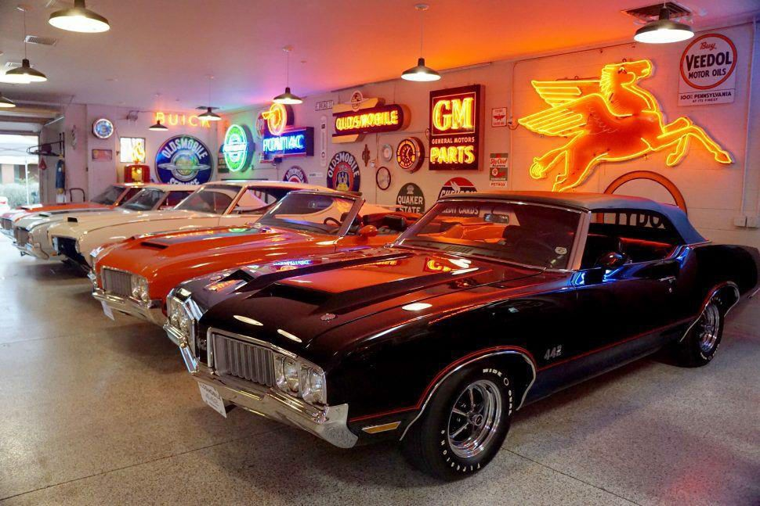

There’s something to be said for knowing what you like, and going deep.

ED NOTE: Longtime Northern Lights member Ray Smitke, has a winter place in Scottsdale, AZ. One of his AZ friends is Fred Mandrick. Ray has told me of Fred’s great collection and has asked Karen and me to join him and Judy one January, to visit Barret-Jackson and to meet Fred and the Olds guys at the Pavilions Mall. I think I may have to take him up on that.

Fred Mandrick’s collection concentrates exclusively on 1968-’72 Oldsmobile A-bodies. Not even four- doors and Vista Cruisers—just two-doors and convertibles. Cutlass Supremes. 442s. W30s. Hurst Oldses. And even a car (and some parts) that never actually saw a production line—but which is an important part of the Oldsmobile story. Fred’s formidable collection features more than a dozen A- body Oldses all told, ranging from low-mileage originals to complete restorations, coupes and convertibles, and a surprising stash of NOS parts. The garage he keeps them in matches many houses we’ve visited for sheer size; it’s decked out in authentic mid-century neon, and has its own attached two-bay workshop. Hanging out next to the fully-dressed W30 455 outside his office is an all- aluminum 455 topped by four dual-throat Weber carbs, as it would have run in the Can-Am series of the early ’70s. The man does not dabble.

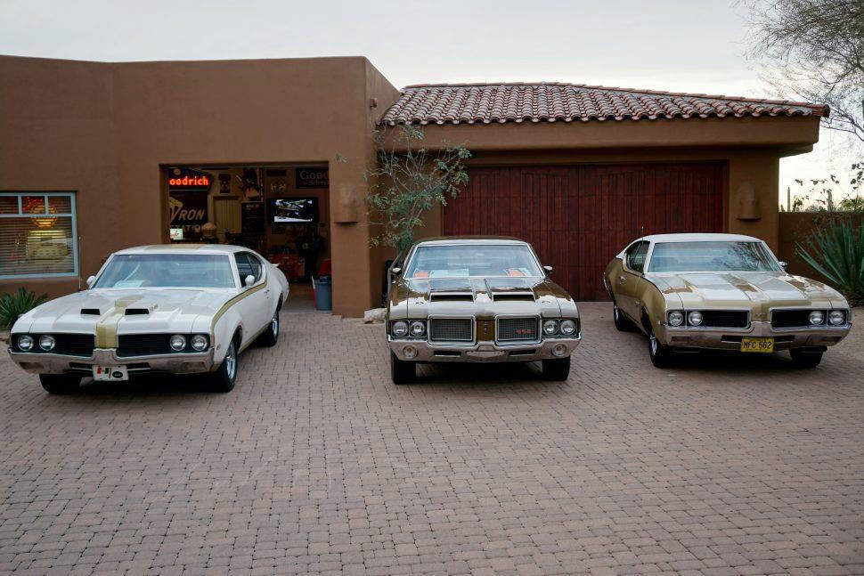

It started with Fred’s parents, who lived in Rochester, New York at the time. “Dad started buying new Oldsmobiles in ’66, and he got to be friends with the dealership owner’s son. He always had to have something new, so we got a new Olds every year from ’66 to ’73—except for 1970, when he had a Riviera. But he always had full-size models—88s and 98s. Fred was particularly taken by Rally Red, which matched a Raleigh Chopper bicycle he got in 1970, at the tender age of 10. “If I couldn’t afford to buy a car, at least I managed to get a bicycle in my favorite color scheme,” he recalls.

“My first car was a ’70 Cutlass Supreme, which I got in 1975. Man, all kinds of firsts happened in that thing!” he jokes. (We think.) “It was a decent car when I got it, with just a little rust. But of course we fixed it up, painted it, and I drove it for about two years through high school.” The brutal winter of 1976-’77 proved to be too much for Fred’s parents, who moved to Phoenix as soon as the thaw hit. “My parents got sick and tired of dealing with the snow; I had just graduated HS and came along for the ride.”

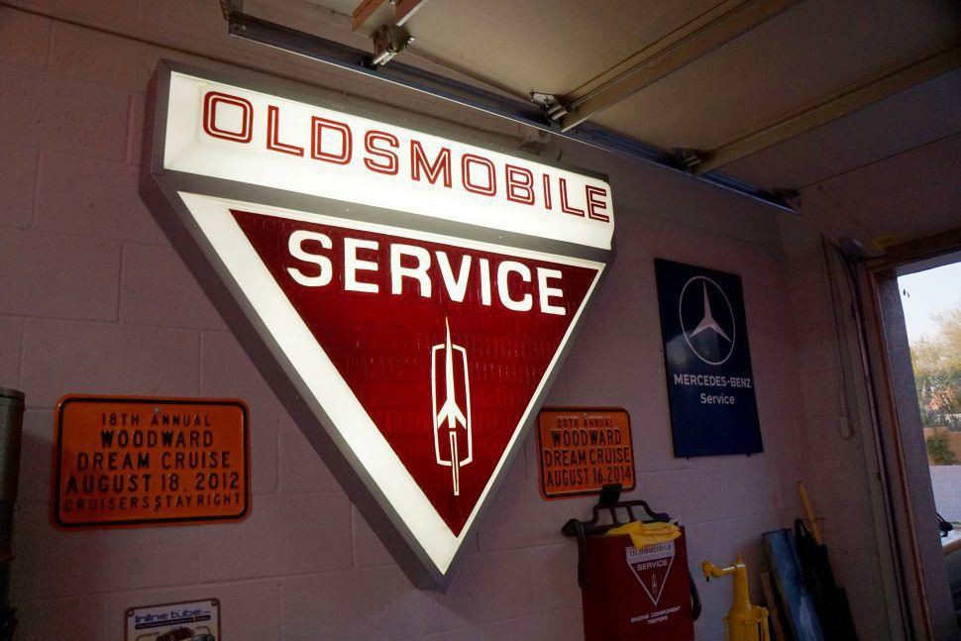

New town, new car: Fred found himself a ’66 Pontiac GTO. “I paid $580 for it; it was a California car with smog pump, air conditioning and a Powerglide. It was all-original paint except for one fender, and I proceeded to mess it up: I put bigger tires on the back, which then scraped on the wheel opening, so then I pounded the wheel opening larger.” Today, the lessons of mis-spent youth have been taken to heart. “Every survivor car I see or own, I’m glad someone didn’t get their hands on it and mess it up.”

His first Arizona Olds was a Rally Red 442 hardtop purchased in the early ’80s. Fred no longer owns it, though he knows where it is. After that, “my collection has gone through two phases. In ’85, I moved to Phoenix from Tucson, and I had a few cars through about 1992. When it came time to start my business, I sold everything. From 1992-2001 I was out of collector cars. In 2001 I started buying cars again. Initially I had an Olds, a GTO, a Superbird, a Camaro… but one after another. In the early 2000s, Oldsmobiles kept finding me. Some of the cars I sold in ’92 started to resurface, and I bought ’em back.”

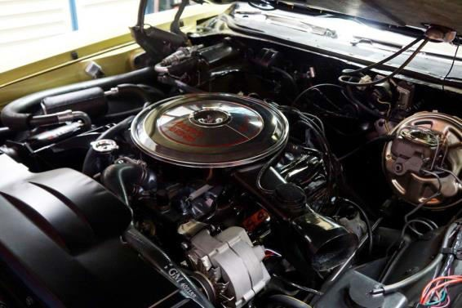

Soon, Fred dispersed all of his other cars – even the ones he liked – in order to concentrate. Within half a decade, he built up a formidable Olds A-body collection. One of each Hurst/Olds—’68, ’69, ’70 and ’72. Half a dozen 442s, not including projects, parts cars and pieces. Like unrestored cars? There’s a 19,000-mile ’68 W30, and a [100,000-mile Rally Red ’70](https://www.hemmings.com/blog/article/son-and-air-1970-oldsmobile-4-4-2/) that looks cleaner than some restorations we’ve seen. There’s even something so rare that most people, even diehard Olds fanatics, forgot it existed— the George-Hurst-built ’68 442 with a complete Toronado driveline (including front-drive transaxle!) that served as a pitch for his company to go into business with Oldsmobile. Fred restored the car nicknamed Fouranado in the garage-attached two-car shop in the space of about a year.

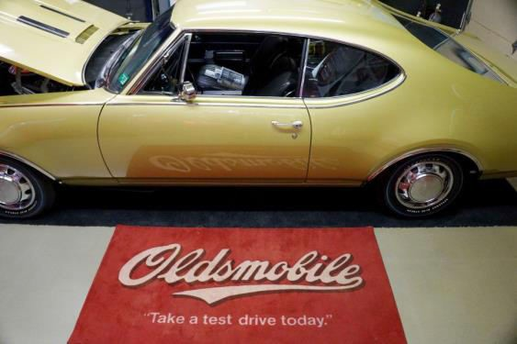

There’s also his parts closet, full of NOS goodies: consoles, shifters, steering wheels. “They’re cool, and they make a difference on the cars when you put them together,” Fred notes. “Weatherstripping is tough. And I’ve just acquired things through swap meets, online, and from knowing people looking to get rid of things. Every day I search for NOS parts. Yesterday I bought rear bumper fillers; NOS ones are so much better than re-pops. I don’t need them now, but I will in the future.” But Fred isn’t operating a parts warehouse. “I rarely sell anything. I have some W-machine parts, but I won’t sell W parts to clone a car.”

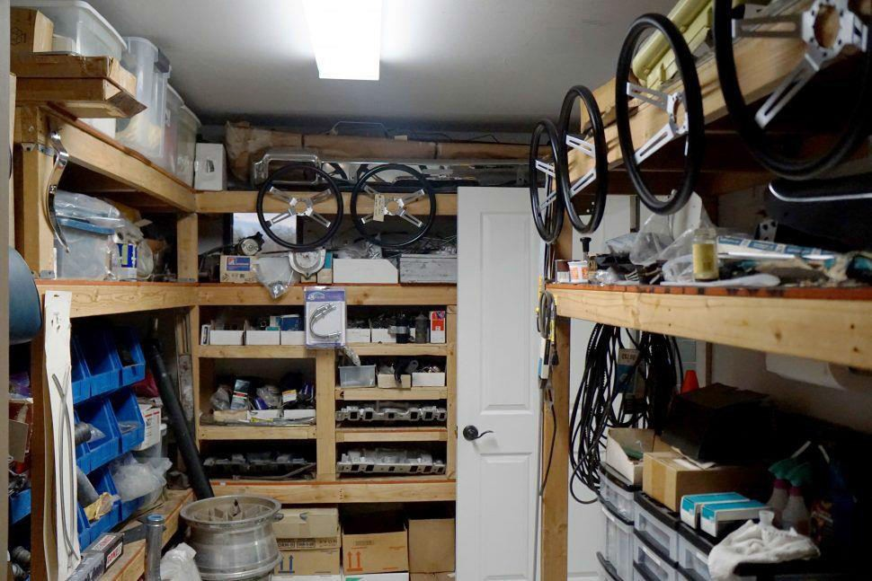

*Even Fred’s parts stock is impressive.*

At this point, he feels like his collection is largely complete. “I mean, a ’70 W31 four-speed would be cool. Or maybe a ’68 Ram Rod with a stick. But that’s all I’d be looking for… I feel like what I have now is pretty complete for me.” Of course, it helps to have a car with sturdy bones to start with. “If something piques my interest, I have two things that I check for. First, how do the doors close? And second, if it’s an automatic, how does it feel when it goes into gear? If they’re smooth, I’ll dig deeper. I got that advice from my dad: smooth doors and smooth shifting will often mean a good car. He hasn’t been wrong yet.”

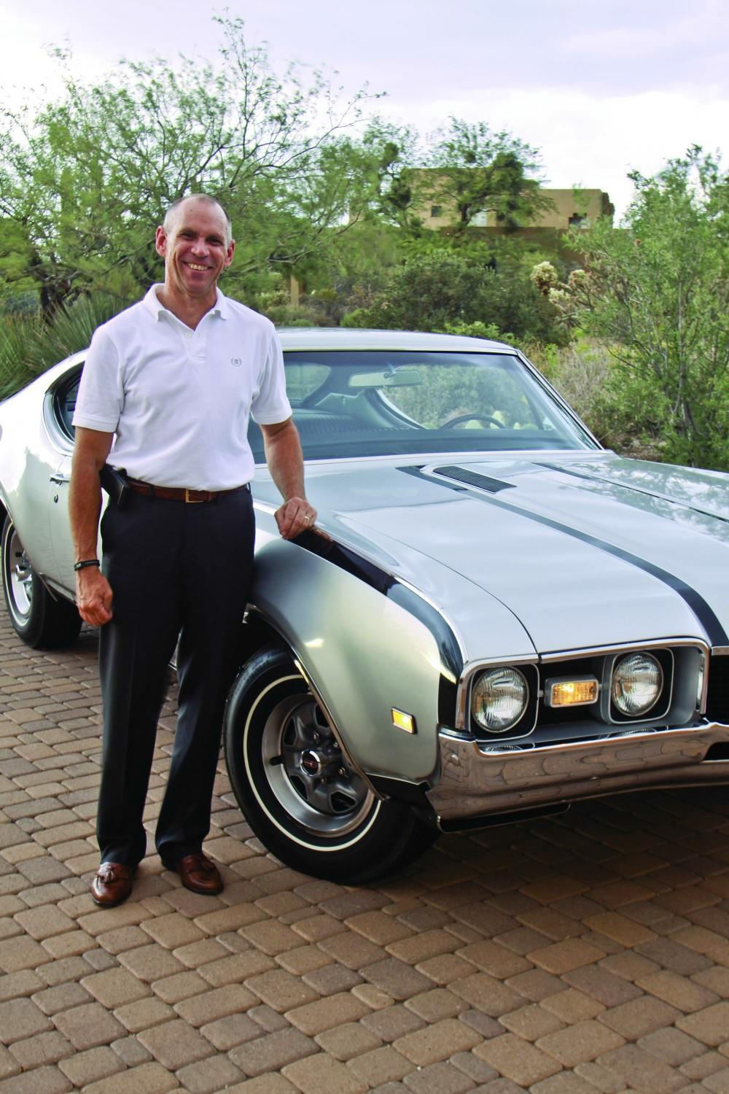

*Fred Mandrick*

## .... .. ..

loti..

....·-.. ....

"

-hio·ha...llu.. .._.I.

-·-..., r.•.l

..

--

- 1.....

loa.,., -]>··-..

......

..

,

I lo _.,,,-.,.,..... ••

...

I ''''" •-.... '"* ,,........., •r ·•••If, C .!... *.*

f-

'" ......... f"puioi

'al'l- . ,............

....,• *..........*

+ "' ,, ••..-

-..'"'"'* *...............* or-Wt k"

'"""' ......."''"" •*"""*'* u.· - • .ou .....

*,\()I* " ()I 1".\IIHIII .P Ill \1 L<lt " \

SPFCI\LJST, \\J'J ll \ll•i\1 Si'liC..:l\LL\ IJt\I,EU \'U

ElJl JI'\II0'T SI'HCI \U) l)f ...tc;'H) I'U f.. I• ffJ

lOl 'lt \\ \1( '11\IJ·C\IC H.Ut 11'\tOI

•• .r 1*J* Uurnc • •• ····· ,.,, lit I • ,., lh 4 ....

.....u...,. • • "' ' '" I I '" "'" lbft"-

·"l>o •nl'fft.l."n,clt .U.tt...,jlllll) ... ,, ' lie ... li.t I'} •f«J ' ,,

"''""' """''"'"" ....,. "' " •• • Ill ... ."I ... r

•• fl lo-.. 6 I r l>f I ' '" ' I» "" " ..... ' ' • w"' "

-"'"" .. I ,, ...Jn..,., I • h ,, • n•lt

•I • *>l>J* " 1 *of* r 1 I .. ..,., .. ' ' •• "' *(!J* .f

...

I<>• *r* f"'" • 'I• '

IHil •

OLDSMOBILE DI\'ION GENERAL

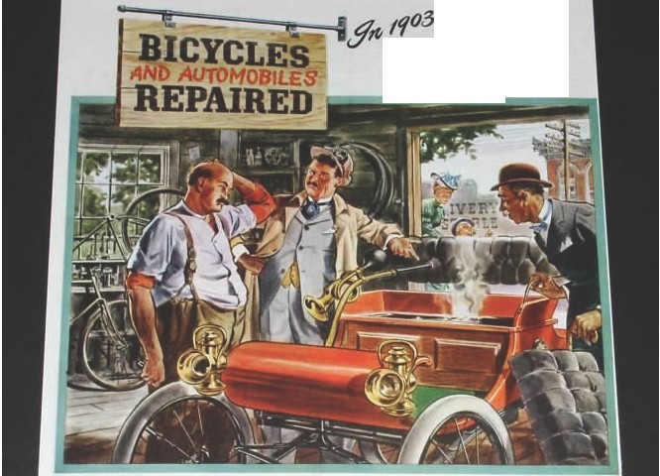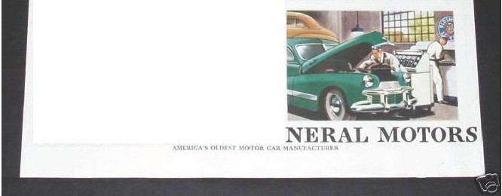

MOTORS

# A Rare '68 Oldsmobile Hurst/Olds is All About the Pound-Feet

Restoration Profile (Hemmings Motor News) By [Barry Kluczyk](https://www.hemmings.com/stories/author/barrykluczyk)

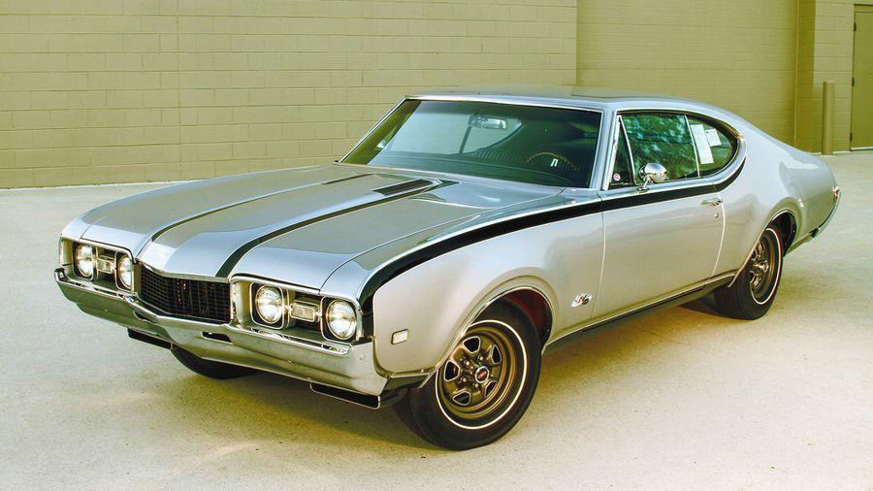

Photography by Barry Kluczyk; Restoration photography by James Kryta

With about 30 Oldsmobile A-bodies that have passed in and out of his garage, including several that he’s campaigned in Pure Stock drag racing, James Kryta has a feel for how a big-block Olds feels out of the hole—but he really didn’t appreciate it until he was behind the wheel of his brother’s GTO at the drag strip.

"It was a totally different experience, because the Pontiac’s power curve is so much different than a 455 Olds," he says. "The Pontiac’s power came on very strong in the midrange, where I was more used to feathering the throttle off the line in my Olds, because there is so much torque down low. They both ran comparable times, but the Olds is all torque all of the time."

That stands to reason when you look back at the history of Oldsmobile’s largest-displacement engine, which was designed to motivate some of the largest lumbering giants in the full-size category. Cars such

as the Delmont 88 were more than two tons of turnpike fun, and 455 cubic inches of big-block power was the effortless way of delivering the family to the next Stuckey’s.

The 455 was introduced in 1968, and the paint was barely dry on the first batch of engines when a number of people began talking out loud about shoving the biggest-ever Olds V-8 into the intermediate A-body chassis. George Hurst would be the guy who talked the loudest and helped make it happen.

Earlier, he’d shopped the idea of a "second stage" specialty performance Firebird model to Pontiac, but the division declined. After all, it more or less invented the "stuff a bigger engine in a smaller car" business model with the GTO. "We got this," Pontiac said, so Hurst took the idea to Oldsmobile, suggesting the Hurst/Olds and the freshly minted 455 engine as its cornerstone.

The ears in Lansing were more receptive, although there was a General Motors rule to bend about limiting the engine size in the company’s intermediate models to no more than 400 cubic inches, which was the displacement of the 4-4-2’s engine. Hurst’s second stage production operation was the work-around solution. They said each Hurst/Olds was built with a 400 and it was changed at the nearby Hurst facility.

"That’s the story and we’re sticking to it," Oldsmobile said. And for a number of years, it was a technicality no one questioned. Today, it’s understood that the 1968 Hurst/Olds’ 455 engines were installed on the line at Olds plant in Lansing, as the logistics of the offsite engine swap would have been time- and cost-prohibitive. That, and the federal government mandated a portion of the vehicle identification number be stamped on each vehicle’s engine, which would have thrown a big wrench in the second-stage swap plan.

Ironically, the H/O’s 455 was actually lighter than the 400 engine it replaced, which made it the engineering equivalent of a box of calorie-burning doughnuts. Also, it wasn’t simply a 455 misdirected from the waiting chassis of your father’s Delmont. The W45-code assembly used the W-30 400’s high- flow D-code cylinder heads and the W-31-spec high-lift camshaft, as well as the W-31 package’s 750- cfm Quadrajet carburetor and a recurved distributor designed to deliver more advance earlier in the rpm band. The result was an advertised rating of 390 horsepower and a gut-wrenching 500 pound-feet of torque — with almost all of it delivered, it seemed, at idle.

For models ordered with air conditioning, the engine package was a little softer, with C-code cylinder heads and a 735-cfm version of the Q-Jet that cost the engine about 10 horsepower, but the torque was still there. A TH400 three-speed automatic was the only transmission choice, regardless of the engine spec, and gear selection was, of course, performed via a Hurst Dual/Gate shifter, which allowed normal automatic operation with the standard PRNDSL pattern or manual operation via a secondary performance gate that locked out Park and Reverse.

With a set of 3.91 gears (non-A/C models) in the unique Olds rear axle, the ’68 H/O was easily a 13- second car, straight off the showroom floor — and it didn’t take much to make one significantly quicker. That

was undoubtedly the intention for the vast majority of orders submitted when word of the car finally reached dealers and their supercar-hungry customers.

The problem was a hiatus in the car’s development drastically curtailed production, as well as the full implementation of Hurst and Jack "Doc" Watson’s original vision for the car. They wanted hidden headlights and a rear spoiler, but by the time the project recommenced, there wasn’t time to incorporate them, although the rear spoiler did make it to production for 1969.

Only 515 were built in the Hurst/Olds’ inaugural year (459 Holiday Coupe hardtops and 56 Sport Coupe pillared sedans). Many were driven straight to the drag strip, where all the 455’s tremendous torque was put to good use. In fact, life on the quarter-mile is how James’ car apparently spent its first few years, thanks to telltales found in the trunk, when he purchased it nearly 12 years ago at a Carlisle event.

"There were stickers from different tracks and there were blown-out air bags inside the rear coil springs," he says. "It was clear it spent plenty of time on the strip."

The original engine was also in the trunk and in pieces, but at least it was the original. The same went for the original TH400 transmission. James also checked with Karl Sarpolis at the Hurst/Olds Club of America (hurstolds.com) to verify the car’s authenticity.

"Karl has a list of all the original VINs and I wanted to confirm this car was on it," James says. "It was, and I felt more confident buying the car, even though it needed a complete restoration."

Fortunately, despite being sold originally in the Rust Belt state of Wisconsin, the car quickly made its way to the drier climes of the Southwest, ripping up quarter-miles in Nevada and California. The dry air worked wonders for preserving the Olds’ sheetmetal, which was straight and solid, but all the soft bits, from the dash pad to the weather stripping, had petrified.

"Those were the easy parts to replace during the restoration," James says. "We were fortunate that all the unique Hurst/Olds parts were still in place, too. Restoring a ’68 Cutlass or 4-4-2 is already more difficult than the 1970-’72 models, because there are fewer parts available, but having to track down the H/O special parts would have made things just that much more difficult."

Those parts included the wood overlay for the dashboard, the Hurst Dual/Gate shifter, and the exterior emblems. We covered the disassembly of the car in the May 2016 issue (*HMM* #153), as well as the layout for the distinctive black-and-silver paint scheme (November 2017, *HMM* #171). Wing’s Auto Art, in Ionia, Michigan, handled the disassembly, bodywork, and painting, while James enlisted Supercar Specialties to help with the reassembly. The collaborative effort garnered a "Best Restored" award at the 2018 Detroit Autorama.

Additionally, the car’s original engine was rebuilt and tuned with the intention of returning the car to its roots: The drag strip. "I built the car with the plan of running Pure Stock drag racing," James says. "With all that torque, it’s a challenge to launch, but it’s a blast when the tires hook up and the car sprints down the track. It’s a great package that really works."

Despite the Hurst/Olds’ high visibility and strong performance, the development hiccup that delayed production limited its market momentum. The H/O returned in 1969, with hood scoops, the rear spoiler,

and a distinctive white/gold paint scheme, but only the "softer," 380-horsepower version of the 455 engine. A little more than 900 of the cars were built that year. By 1970, Oldsmobile offered the 455 as a regular-production option in the Cutlass/4-4-2 lineup and that eliminated the signature feature on which the Hurst/Olds was based, so the car was discontinued.

The H/O returned in 1972 and additional models were offered every few years, into the Eighties. These cars were largely appearance packages, although the 1973 model received a hotter camshaft and the 1979 Hurst/Olds was the lone GM A-body coupe to feature a 350-cubic-inch V-8 engine that year. Still, it was only the 1968 and ’69 models that were distinguished with the unique big-block engines.

"It was the quintessential muscle car: Big engine in a smaller vehicle — and an appearance that said it wasn’t like any other regular model," James says. "And for Oldsmobile, which wasn’t known for flashy cars, it was something truly special."

George Hurst was onto something with the Hurst/Olds. Regardless of whether it conveyed his true vision, it left an impression — much of it in rubber shed by 500 pound-feet of torque, available at the merest twitch of the right foot.

**OWNER'S VIEW**

Most of the Oldsmobile A-bodies I’ve owned have been the 1970-’72 models. They’re simply the models I prefer, but there was something about this ’68 Hurst/Olds that tugged at me, and the more we got into the restoration, the more I began to appreciate just how unique these cars are. The W-45 engine was a one-year-only production and the performance is on par with anything from the era. The more time I spend with it, the more I love it. There’s nothing else really like it. —James Kryta

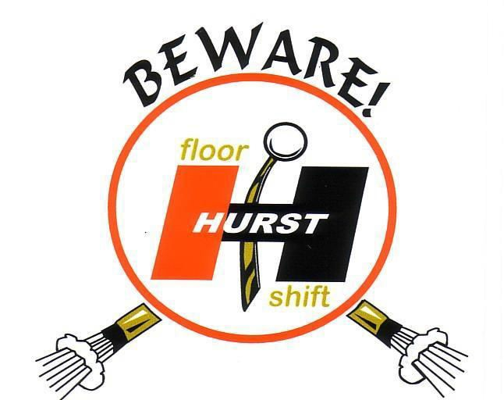

# Tech 101 - How to make a car last longer

By [Kurt Ernst](https://www.hemmings.com/stories/author/kurt)

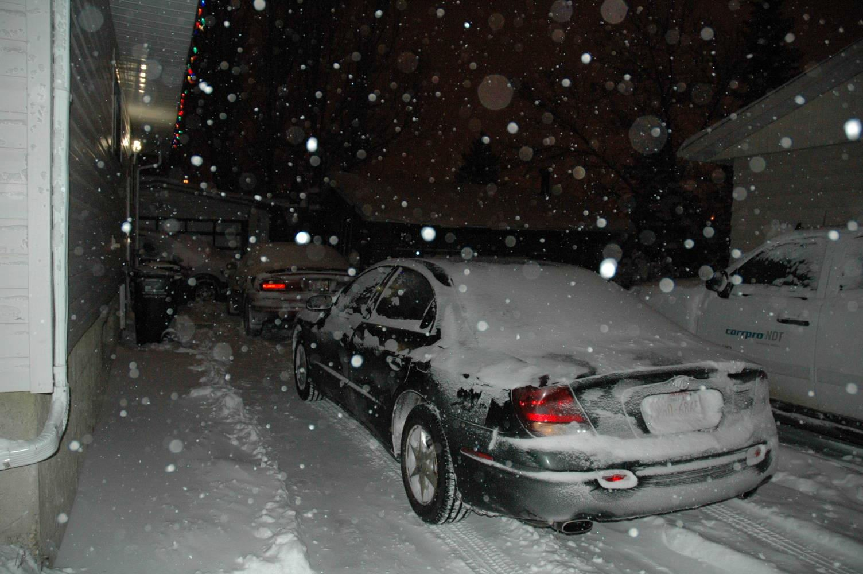

Aside from buying a house, purchasing a car is the most expensive transaction that most consumers will make over the course of a lifetime. Prices for the average new car are hovering in the $30,000 range, prices for (most) used cars remain high due to strong demand and the U.S. median income failing to rebound to the pre-crash years of the last decade. Combined, these factors mean one thing: Americans are holding onto vehicles longer than they have in recent decades. While most collectors are fanatical about the care and feeding of prized automobiles (explaining how a car can look showroom new after decades of use), those new to the hobby, or those simply planning to keep a vehicle beyond the traditional five or 10 years, may still have questions. Below are 10 tips to get the longest possible life out of a vehicle, whether it's showroom-fresh or a beloved family member that's flipped its odometer once or twice.

1. Storing your car? Think twice about starting your engine. Starting your engine, especially in cold weather, produces the bulk of the wear on your engine's internals. In his book *Drive It Forever*, author Robert Sikorsky claims that as much as 95 percent of an engine's wear is caused by the first 10 seconds of running after a cold start; put another way, every time the engine is started cold, it produces the wear equivalent of 500 miles of travel with a warm engine.

To understand why, it's best to think of an engine's bearing surfaces as sheets of sandpaper, because that's what they'd look like under high magnification. During a cold start, there is no wear-reducing film of oil between these surfaces, meaning that microscopic particles of metal (like grains of sand from the imaginary sandpaper) are dislodged into the oil. This wear diminishes as oil reaches internal components, but the film of oil on bearing surfaces can be displaced in as little as six seconds after shutting off the engine. In other words, "cold" doesn't actually mean "cold to the touch." To minimize wear, try to reduce the times you start a cold engine. Never start an engine just to hear it run, or just to "circulate the oil;" if you're not going to drive it to full operating temperature, consider other options.

1. If at all possible, avoid short trips in cold weather. To function at peak efficiency, an engine needs to be at its peak operating temperature, roughly the temperature at which its thermostat is designed to open and allow coolant to circulate. The amount of time needed to reach this operating temperature varies by driving style and outside temperature, but a bare minimum under warm conditions is likely going to be between five and 10 miles.

Driving shorter distances in cold weather can cause condensation inside an engine, leading to the potential of internal corrosion. It can also cause the formation of sludge in engine oil, as contaminants that would be burned off at normal operating temperature are trapped in the oil, ultimately settling to the bottom of the oil pan as deposits and sludge.

Also, avoid turning on the car's cabin heat until the coolant has reached its normal operating temperature, as doing so will prolong the amount of time it takes for the engine to reach peak operating temperature.

1. Never ignore a warning light. Modern instrument panels are wonders of design and packaging, with some modern cars rivaling aircraft for the amount of information potentially displayed. Even those incapable or unwilling to learn what an oil pressure or coolant temperature warning light looks like should know this: Generally speaking, yellow lights mean that something is wrong and needs to be looked at by a competent mechanic as soon as possible. Red lights, on the other hand, mean pull over as soon as it's safe to do so. Spin a wrench for pay long enough, and you're bound to run into "that customer," the one who destroyed a brand-new car's engine by ignoring the glowing red "low oil pressure" light for days, until the car "made a horrible noise and then stopped running." Paying for (at best) a new short block is a very expensive way to learn that warning lights, especially red warning lights, are there for a valid reason.
2. Don't rely solely on mileage to judge oil change intervals. As we've already discussed, motor oil traps all kinds of things that are bad for a car's engine. According to Sikorsky, byproducts of the combustion process include sludge, varnish, sulfuric acid and hydrochloric hydrobromic acid, and none of these will benefit your engine's internals if left too long. Most manufacturers now have recommended oil change intervals based on time as well as mileage, but as a general rule of thumb, don't go longer than 12 months between oil changes (unless the car is in storage and not driven at all).
3. Brake fluid is not a lifetime component. Changing the brake fluid in a modern automobile may be the most widely ignored maintenance procedure, as most motorists don't even know that doing so is recommended. Brake fluid is hygroscopic, meaning that it attracts water. The more water brake fluid absorbs (which is inevitable over time), the lower the brake fluid's boiling point becomes and the more that drivers risk corrosion of internal braking system components. In the case of modern antilock braking systems, these components may be an order of magnitude more expensive than brake system

parts of a few decades back. Always follow brake fluid replacement guidelines established by your manufacturer, but as a general rule of thumb, change brake fluid at least every three years.

1. Beware of technicians bearing impact guns. Most modern automobiles have factory torque values for lug nuts or bolts in the range of 85-95 pound-feet. A contemporary 1/2 inch-drive impact gun can spin these on with a force of over 500 pound-feet of torque, potentially causing damage to wheels, wheel studs, lug bolts, hubs, brake rotors and brake drums. Perhaps worse, the chance that the average motorist will be able to remove such over-tightened lug bolts with the factory-supplied wrench, by the side of the road, lies directly between "slim" and "none."

When taking a car in for service that requires removal of the wheels, always request that the nuts (or bolts) be torqued by hand, with a torque wrench set to the manufacturer's recommended value. For those with a lug wrench and torque wrench at home, taking a few minutes to double check a shop's work will ensure that no surprises await the next time a roadside tire swap is necessary.

1. Consider winter floor mats for daily drivers. While most people know that deeply channeled rubber floor mats are a great way to keep carpets dry, they're also the best way to keep road salt (picked up on shoes and boots) from leaching through carpeting and attacking sheet metal or electrical components underneath. Though modern cars use galvanized (or otherwise treated) steel, there are still components beneath the carpeting (such as expensive control modules and electrical connectors) that won't benefit from immersion in salt water.

Footwells also see a significant amount of dirt and gravel, meaning that anti-corrosive coatings can be worn away over time. Though winter floor mats may seem like an expensive luxury item, they're far less expensive than troubleshooting electrical gremlins or coping with rust holes in the floorpan.

1. Don't ignore the outside of your daily driver, especially in winter. Many drivers otherwise diligent about keeping cars clean give up entirely when the temperature drops below freezing. Even if you can't wash a car at home, it's still a good idea to run daily drivers through a car wash on a weekly basis to minimize the buildup of dirt and road salt. Also, never neglect the end of season waxing in preparation for winter, and touch up paint chips (temperature permitting) before they begin to rust. Even in fair weather, contaminants like bug guts and bird droppings can quickly etch or otherwise damage paint, so they're best removed as soon as possible. Brake dust is corrosive and can etch (expensive to replace) alloy wheels, so it should never be allowed to accumulate.
2. Obey your manufacturer's maintenance schedule religiously. Ask the owner of any hyper-mileage car what the secret to their success is, and each will say without hesitation "following the factory's recommended maintenance to the letter." In addition to service items already mentioned, vehicles routinely need items like transmission fluid, transmission filters, air cleaners, differential fluid and coolant checked and changed at varying intervals. Even components like shock absorbers and suspension bushings wear out over time, and replacing them as preventative maintenance can stave off more expensive repairs down the line. As an added bonus, strictly adhering to a manufacturer's maintenance schedule will make the vehicle easier to sell, if and when the decision is made to do so.

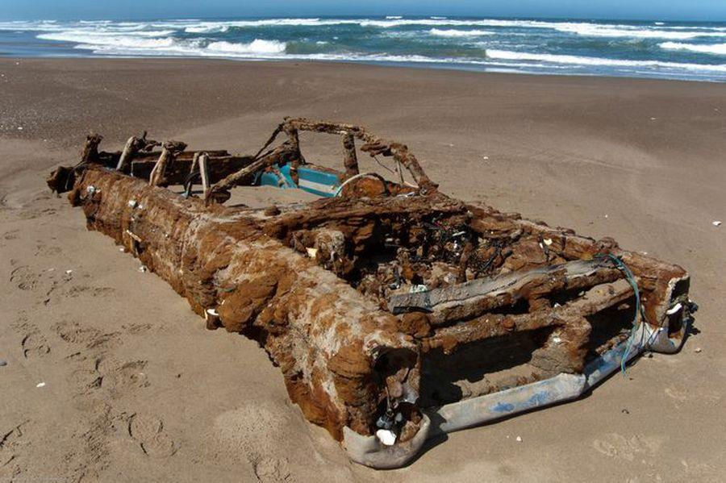

*The remains of a1964 Pontiac Bonneville, found on Morro Beach, California.*

1. Break it in right. If you're lucky enough to take delivery of a new car or a new engine, follow the manufacturer's or builder's instructions on break-in to the letter. Avoid the old advice that engines should be run hard out of the crate to be "fast"; if anything, engines run without proper break-in are more prone to be problematic throughout their lives. While advances in materials and manufacturing have produced engines with much tighter tolerances (needing less break-in), the gradual wearing-in of metal-on-metal components helps to ensure extended life.

Ed. Note: I had an old Firebird I was getting rid of. It started but the body was shot. It leaked oil like a sieve so after seeing an infomercial on a new product Dura Lube, I thought I’d try it. On TV, they ran the car without oil. So since I wasn’t keeping the car, I decided to try it. Karen asked one day why I had the Firebird in the driveway because it leaked so badly. I told her I was doing an experiment. After 1 month of driving back and forth to work (30 km / 20 mi), the car ran fine. No noise, no leak. Apparently, the Dura Lube bonds with the metal. In the show they used it in a new engine and after 100,000 mile they disassembled the engine and could still see the honing marks. The commercial did say to let an engine break in before using the product. They also warned against using it in a posi differential where friction is required. As I see it, if used in the engine, this would reduce any damage on cold start up. Then again, these are my observations. I am not a mechanic and I would not recommend to anyone, to run their car without oil.

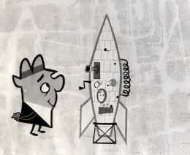

**Members are entitled to a free ad per issue (ad size dependent on space available). Ads must reach us at least two weeks before the next issue Deadlines: Dec 15, March 15, June 15, Sept 15. Not all ads are from members. Please use discretion when purchasing. Buying in person is best. Buyer beware. All prices are in CAD (Canadian Dollars) unless otherwise indicated.**

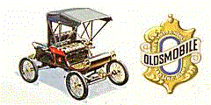

*CARS FOR SALE CARS FOR SALE*

24

**1938 Oldsmobile**; **$41,000** Restoration took previous owner, a retired machinist, approx. 25 years to complete; multi trophy winner. Nice running vehicle. An original car with exception the transmission was updated with a 5 speed, so cruises closer to hi-way speeds. Last safety inspected in June 2020. Can drive home. Was appraised in 2018 at **$56,000**. Owner lives in Olds, Alberta. Can phone and leave a message at 403-556-7686.

**1948 Oldsmobile Sedan**. Have to many vehicles . This car is a head turner. Looks good and drives good. Has a newer 350 chevy engine in it. It has almost no rust .( surface rust only ) . Any question please call or text me at 250 919 2713 in Cranbrook BC (Alberta registration) **$9,500**

**1959 Oldsmobile Eighty-Eight** 2 door hardtop fast back 8 cylinder automatic power steering power brakes, air shocks Interior like new body and frame like new dual exhaust push pop button doors Looking for trades Older Mopar, Older Mustang or **$30,000** Midland, ON call 705 527 0344

**1961 Oldsmobile Super 88 Holiday, 4 dr Hardtop**, 394 ci 4 barrel V8, 3 speed automatic, power steering, power brakes. Car run and drives good, recent rebuilt motor, lots of new parts. Car needs some finishing touches to get it on the road, also comes with parts car. Asking **$6,500** For more info call 780-445-4096

**1962 Oldsmobile Starfire**, auto, 5000 miles on rebuilt 394, dual exhaust, new tires, factory wheelcovers, all glass and trim good, rechromed rear bumper, power windows, power aerial, power trunk, needs headliner and seats recovered, same owner for 28 years, original Saskatoon car. **$20,000 obo** 306- 221-5561

**1966 Oldsmobile Cutlass**, moteur 350, roule très très bien, planchers et frame très propre, freins refaite a neuf, intérieur en bonne condition, échanges accepter, Tel. 514-247-5555 Montréal (*350 engine, drives very very well, floors and frame very clean, brakes redone, interior in good condition, trades accepted*) **$17,980**

**1968 Oldsmobile Cutlass S Convertible** Project Car. On Blocks, No chassis, engine or drivetrain. For sale as is. Great opportunity for a resto mod project! Selling for family as downsizing and health prevent moving forward. Bring trailer and no reasonable offer will be refused. **$3,950 O.B.O** Please contact or text Daniel. 780-257-0352

**1969 Oldsmobile Cutlass S Holiday Coupe** this is a great driving car must see all redone with lots of upgrades rebuilt engine trany diff. just added disc brake kit new headers car run and sounds great. 50865 original miles call Ray 780 922 2548 or 780 970 7182 for more info. **$32,000** Sherwood Park. Will consider trade for newer Rav 4

**1970 Oldsmobile Toronado GT** 455 (400 HP) Oldsmobile guy has all the parts to finish. **$4,420** Edmonton. Guy 587-568-3961

**1972 Oldsmobile Cutlass Supreme** . Runs and drives . Needs exterior restauration and don’t have the time . Beautiful car in and out !! Text only 403 612 4834 **$12,000** Calgary

**1976 Oldsmobile Vista Cruiser** Low mileage Rare one owner Vista Cruiser classic wagon bought new in edmonton.. runs and drives like new. Rust free. Mint interior. Rare roof rack, woodgrain Pkg., and 3rd seat option. **$10,000 obo** Call Mike 780- 812-1306

**1976 Oldsmobile Delta 88 Coupe** 84,000 miles, no rust, no accidents, stored in garage fully loaded with 455 V8. Red with white ½ vinyl roof and white interior. 2nd owner **$5,000 obo** MB. 204-425-8128

**1977 Oldsmobile 442** Putting some feelers out there as this Car is dear to my heart. Grew up with it as our family car. My dad was the original owner, sold it to a gentleman in 2013. I bought it back from that gentleman in July of 2020. Car runs great and I have been using it as an everyday commuter this summer. Non original 455 Big Block Engine, Edelbrock Performer Intake, Olds Cutlass Header, 750 Edelbrock CFM Electric Choke, New Tires, New Shocks, new Magnaflow dual exhaust **$14,999** Red Deer 403-742- 8820

**1992 OLDSMOBILE CUSTOM CRUISER** 4300 made for the

USA as this car was not offered in Canada at the time. Has 3rd row rear seat facing outwards. Car is in immaculate condition. Spent

most of its life in Florida and then Vancouver Island. Car has recently passed an out of province inspection with flying colours. Light blue with gray cloth interior. Rear tailgate opens like a door

and a truck tailgate. 146,000 km. (90,720 mi.) on the optional 350 TBI V8 engine and has the optional sunroof. Brand new radial

white wall tires. Car is in Edmonton. **$12,900**. Look it up on Facebook Marketplace or call Matthew at 780-231-8887

*PARTS FOR SALE PARTS FOR SALE*

2**- 1969 Olds 442 rear bumpers** w cutouts- **$100.00** /both **4 spoke steering wheel**, under dash **8 track player** (black in colour), Numerous 69 and 70 Olds Cutlass & 442 parts for sale… **Oldsmobile 394 Engine** complete from Carb to pan – ran when pulled **$100**. Also have many misc 1969 GTO parts. Call Ray in Edmonton at (780) 975-6477

**1930-’80 Oldsobsolete** has a large inventory of **GM NOS parts** from the 1930’s to the 1980’s. 100,000 parts shelved by part no. Ph 406-777-3221 (P.M. Montana time) e-mail - [parts@oldsobsolete.com](mailto:parts@oldsobsolete.com) . Browse stock at [**Oldsobsolete**](http://www.oldsobsolete.com/product-category/oldsmobile-parts-for-sale/)

[https://www.oldsobsolete.com/product-](https://www.oldsobsolete.com/product-category/oldsmobile-parts-for-sale/)

[category/oldsmobile-parts-for-sale/](https://www.oldsobsolete.com/product-category/oldsmobile-parts-for-sale/)

**GM 1970's Repair Manual $15**

GM 1970'S plus 1980 Vehicle Diagnosis and **repair manual** . Very good condition. Genuine GM Publication.

Also might have 4 **factory rims** from a 1975 Olds Cutlass Supreme. Contact Derek (Calgary) 403-862-9069

**Oldsmobile heads** for 215 cubic inch engine (3 pair) all excellent - $300/pr. 1961 Cutlass auto transmission / Misc. 215 engine parts (no blocks) / Mallory Mini Mag for 371-394 cubic inch engine, great for rod. Rick 306- 679-7888 SK

**Oldsmobile Heads** for 400-425-455:

**1968 C heads**, older build can bolt right on, comes complete with springs and valves. Casting 394648. Painted 455 blue **$300**. **1970 E heads.** Good condition. Will require rebuild. **$250** Ken, Sherwood Park, AB 825- 439-1976

**Oldsmobile Intrigue Repair Manual** (3 books). **$30**

Ken 825-439-1976 AB.

**Oldsmobile 425 engine** complete block # 389244D with heads # 884548 phone 780-686-7897 **$425**

**1968 CUTLASS DRIVERS DOOR**, For 2 Door Hardtop

or Convertible.Complete with Glass, Very Straight and

Solid. ( Best one I’ve seen!) **$380**. Call or text 780-246- 7044.

**1959 Oldsmobile Dynamic 88 Emblems $80 pair** CALL OR TEXT ONLY Call 780-953-5688 Edmonton

**1966 Toronados** parts. Let me know what you’re after. Have stripped 3 cars. Located in Barrhead Alberta. Can ship anywhere. 780-674- 3360

**1950's & 60's** Oldsmobile Dealership Sales **Brochures**

**$20** 780-434-2813

**1976-77** 2 door Cutlass **rear bumper.** VG condition, c/w bumperettes and impact strip. Call or text 825-439-1976

1970-72 stainless steel **wheel opening molding**

1971-72 Cutlass Conv. **Trunk lid** 14” x 7” bolt on **SSI/II rally wheels** 1973-76 455 “J” **heads** rebuilt

1970 Cutlass & 442 Rad Support c/w headlight pots 1975-77 Cutlass Supreme Hurst **T-Top glass**

1970-77 misc. Cutlass and 442 **body and engine parts**

1976 Cutlass S and 1977 442 Headlight doors Call Steve for pricing 403-244-7007 Calgary, AB.

**1968 Oldsmobile Cutlass Coupe Side Glass**. Complete set (6 Pieces) Good used Condition. **$350**. Set. Window Regulators

$75. Each. Rear Window $100. Stainless Steel Trim for Vinyl Top ( all 7 Pieces) Good Condition. $200. Rear Window Stainless ( all 4 Pieces, Nice Condition) $125. Call or text only

780-246-7044.

**1968-69 Oldsmobile Cutlass 442 Am radio**, with FM Bluetooth Aux and RCA outs added. Mint condition radio with no pitting in the chrome at all. 1 year warranty. Calgary **$400** 825-994-1194

**WANTED**

**1976-77 Rear bumper** for a Cutlass Supreme, Dave

204 729 5808 [burba@mts.net](mailto:burba@mts.net)

**1970-1972 Oldsmobile Cutlass Supreme convertible**. Ph. Barry in MB @ 204 771 1680 or [barrysmitke@gmail.com](mailto:barrysmitke@gmail.com)

**Dash Pad** For 1968 Cutlass/442, in good condition and **Quadra jet carb** # 7028251 or # 7028253 email [Nichols@platinum.ca](mailto:Nichols@platinum.ca) or telephone 403 938-1855.

**3 speed tranny** for 64 Dynamic 88. Contact Dan at 780-489-

6962

**1964 Cutlass wheel well moldings** (2 front & 2 rear) good condition (no dents or rust) and fits only 1964 models, preferably, 2 door HT, 2 door Post and 2 door convertibles. Contact Cecil (403)242-8625. If leaving a message, please indicate name and phone number.

**FREE STUFF**

**2001 Oldsmobile 3.5 V6** “Short Star” Great engine for any project. Torque 230 ft-lbs. @ 4400 rpm, Base engine size 3.5 L, Horsepower 215 NET hp @ 5600 rpm, Valves 24, Base engine type Gas, Cam type Double overhead cam (DOHC), Bring your truck and take it away. Ken 825-439-1976 Sherwood Park



25

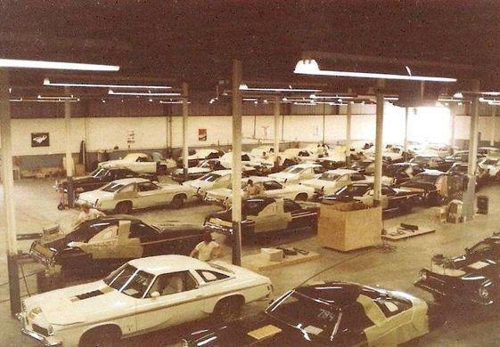

Cameo white and Ebony black 1973 Cutlass 442s being converted to Hurst/Oldsmobiles

26